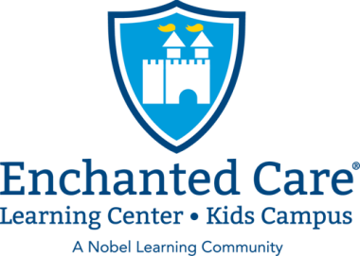 | Dublin News
February 2020
In This Issue  - Message from Admin  - Events  - Reminders  Contact Information  Enchanted Care Dublin  614-798-1403 | A Message from the Administration Team  Our kids love to be creative and learn. February is a great time for our teachers to get their creative minds flowing with fun and engaging indoor activities when the weather prevents us from outdoor play. Our teachers are working hard on preparing activities to help the children learn and grow with our curriculum.  Please make sure you look at all the upcoming events. Special events such as The Sweethearts Dance & Parents Night Out are a wonderful time to spend with our families, and we hope that we will see you all there!  Here is what is happening in January:  Little Caesars Order Form Due Date  Order forms are due to the school by Monday, February 3rd.  - Monday, February 3rd - Wear Your Favorite Sports Team  - Wednesday, January 5th - Breakfast To Go.  - Friday, February 7th - Our Sweethearts Dance  - Tuesday, February 11th - Valentine’s Mail Day  - Wednesday February 12^{th -} Lincoln’s Birthday  - Thursday, February 13th - Classroom Valentine Card Exchange Day  - Friday, February 14th – Parents’ Night Out  - Monday, February 17th – CLOSED for Professional Development Day  - Friday, February 21st – Dress Like a Fairy Tale Character  Day  Valentine's Mail Day / Class Valentine Card Exchange  Valentine's Mail Day- February 11th  This is a day were parents can write a Valentine’s Day card to your child, bring it into school and put it in our Valentines mailbox. Your card will be read to your child during their classroom's circle time.  Class Valentine Card Exchange- February 13th  On February 13th the children will be doing their classroom Valentine's exchange. Just a reminder to please not bring in food items with the Valentines due to allergies within the school. Below are listed the number of children in each class so we can assure the right number of Valentines.  INFANT: 8  TODDLER 1: 7  TODDLER 2: 6  BEGINNERS: 18  INTERMEDIATE: 15  PRE-K B: 14  Reminders…  NO SCHOOL REMINDER:  There will be no school on February 17th. Our teachers will be busy with a full day of professional development. We can't wait to implement the new things we learn in our classrooms!  Parent Ambassador Program – We are looking for a few parent ambassadors to help promote our school to potential families. This also provides you with the opportunity to earn free tuition! If you are interested in becoming a Parent Ambassador for Enchanted Care Dublin, please reach out to the Administrative Team.  Referral Program - We have an amazing referral program! For each family you refer to Enchanted Care (any location) you will receive FREE TUITION for one week.

