**When Not to Help Your Child: Fostering Independence and Confidence**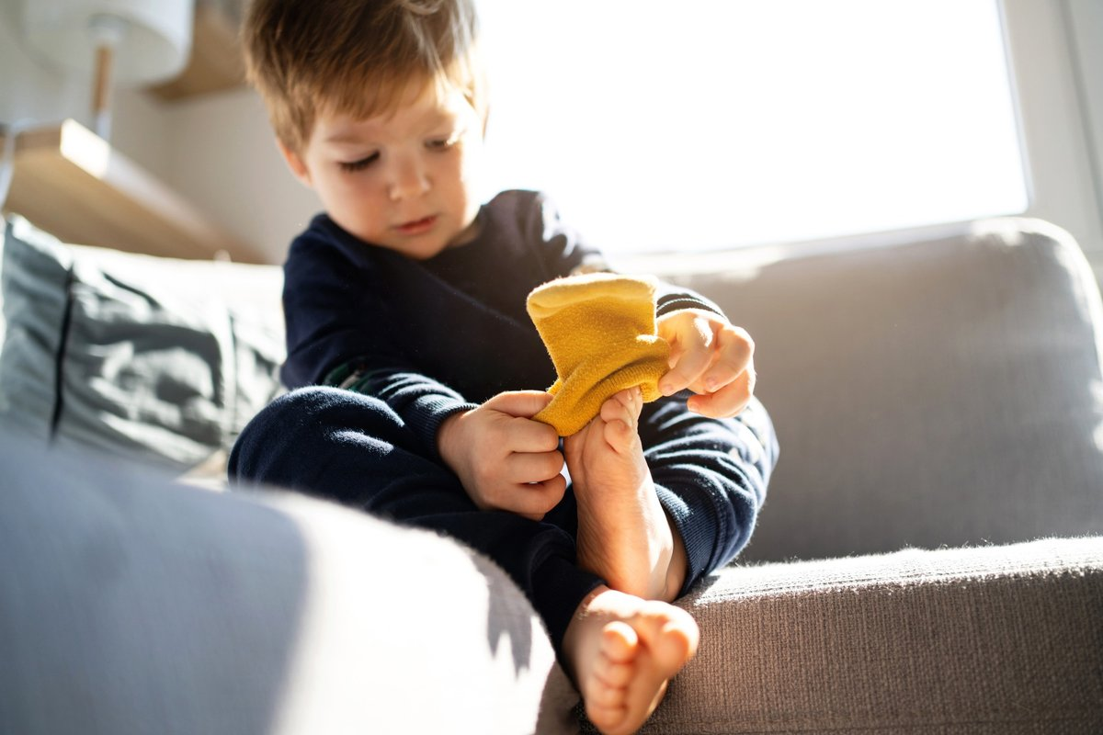

As parents and caregivers, it’s natural to want to step in right away when we see our child struggle. We want to make things easier and faster and avoid frustration. But sometimes, the kindest way to support children is by letting them figure things out for themselves. Every day, at school and at home, your child encounters opportunities to feel the joy of accomplishment. It’s our job to give them the space for success.

## **Building Independence at School**

We believe that fostering independence and teaching kids self-confidence in the early years is one of the greatest gifts we can give. Our classrooms are designed to encourage responsibility, self-care, and confidence with teachers who guide children patiently as they practice doing things on their own. Would you believe that toddlers can help clean up after they eat? It’s true! In our toddler and 2-year-old classrooms, children bring us their dishes after meals, help tidy up toys, and locate their own coats when it’s time to head outside.

By the time our students are ready for kindergarten, they’re independent in many everyday skills—zipping coats, washing hands, following routines, and even taking on classroom jobs. Our teachers model these skills, then step back to let children try on their own. Often, this means standing nearby with patience and encouragement as a child wrestles with a zipper or carefully pours water into a cup.

And when they succeed? The look of pride on their face says it all. These “I did it myself!” moments help children’s confidence bloom and grow. It’s one of the many benefits of letting kids do things on their own: children not only gain practical skills but also learn to believe in their abilities.

## **Encouraging Independence at Home**

There are lots of ways to encourage independence at home, too. Check out our list of suggested activities. At first, you may need to model these skills. Over time, let your child take the lead.

* Watering plants with a small cup or watering can
* Setting napkins on the table at mealtime
* Putting toys away into labeled containers
* Pouring and serving using a child-sized pitcher or spoon
* Practicing dressing skills such as putting on socks, shoes, or coats
* Helping with clean-up by wiping a table and bringing their dishes to you or the sink
* Building self-care habits like brushing teeth or washing hands

**Why Parents Shouldn’t Always Help**

It’s only natural to want to jump in when your child is struggling, but stepping in too soon can keep them from growing. Kids need the chance to work through tasks on their own so they can build persistence, coordination, problem-solving skills, and a genuine sense of pride. Without those opportunities, they may begin to doubt their abilities—when often they just need a little more time and space to figure things out.

By holding back, you’re allowing your child to experiment, make mistakes, and discover solutions. If you notice them fumbling with a button or sorting toys into the wrong bin, try not to rush in. Instead, encourage their effort with simple phrases like, “You’re doing great!”, “Almost. You can do it!”, or “It’s okay, take your time.”

It’s also important to let go of perfection. A backwards sock or a bed that wasn't made quite right is fixable. What matters most is that your child is trying and learning.

**A Community that Builds Confidence**

At school and at home, children thrive when adults work together to support independence. Our teachers guide children through daily routines, celebrate their achievements, and encourage patience as they learn new skills. When parents also incorporate these strategies at home, children gain consistency, confidence, and trust in their own abilities.

These early moments of independence add up. Each time a child pours their own water, zips their jacket, or solves a simple math problem on their own, they are learning more than just a new skill—they are building confidence for a lifetime. Over time, these experiences help children believe in their own abilities so they can say with pride and certainty, “I can do it!”

To learn more about how we build independence and confidence in our students, contact us today!