**The Benefits of Small Group Learning in Centers**

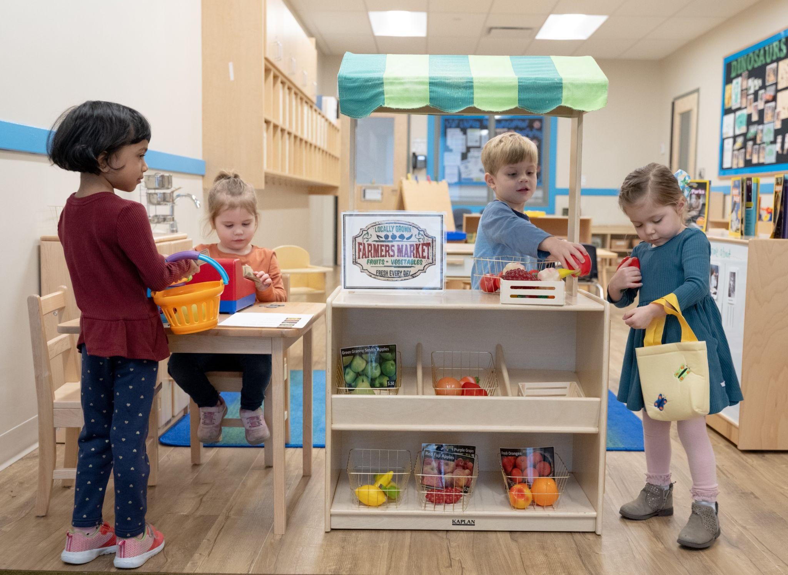

At our school, we believe that learning happens best when children can explore, create, and play in meaningful ways. That’s why our preschool classrooms are designed around center-based learning. “Centers” are clearly defined areas where small groups of 2 to 6 children gather to explore materials, work together, and make discoveries. This type of hands-on play helps children connect abstract ideas to real-world experiences. Let's dive into what centers look like in our classrooms and explore their benefits.

**Center-Based Learning in Action**

Our classrooms feature a variety of Centers designed to encourage small group engagement, including Language & Literacy, Dramatic Play, Math, Science, Construction, and more. Each Center builds on different skills, but they all foster collaboration and communication and spark new ideas. For example, while experimenting with magnets in the Science Center, one child’s curiosity might ignite a group investigation. At the Writing Center, classmates may inspire each other to add details to their stories or drawings. These moments are rich with opportunity as they help children learn from one another.

**Why Small Group Learning Matters**

Small group activities for preschoolers offer a calm, focused space for learning and allow for more individualized attention. While children explore within the Centers, our teachers spend time with them in small groups. They guide play, ask questions, and support learning that fits each child’s needs. In these safe, encouraging settings, children are more likely to try new things and grow their confidence.

**How Small Groups Support Social Skills**

One of the key benefits of small group learning is how it builds social and conflict resolution skills. When preschoolers work together, they learn to share, take turns, and listen to others. Children in the Dramatic Play Center may take on roles like shopper and cashier. At the Construction Center, they might work together to build a sturdy house for the Three Little Pigs. These group activities help children form friendships and learn how to be part of a team, essential skills for school and life.

It’s important to note that independent exploration has value, too. Children sometimes engage with Centers on their own, following their interests and making discoveries at their own pace. Independent exploration fosters self-direction, focus, and confidence. During these quiet moments, teachers remain nearby, offering gentle guidance and support as needed.

**Why Choose Small Group Learning for Your Preschooler?**

Choosing a preschool program with a focus on small group activities gives your child many advantages. They receive personal attention, practice social skills, and learn in a way that builds confidence and curiosity. Our center-based learning approach reflects our commitment to nurturing confident, capable learners. We’re proud to offer an enriching preschool experience where small group learning and working together make a big difference. To learn more about our center-based learning approach, contact us today!