**Ready for Summer Fun: Essential Sun and Water Safety Tips for Young Children**

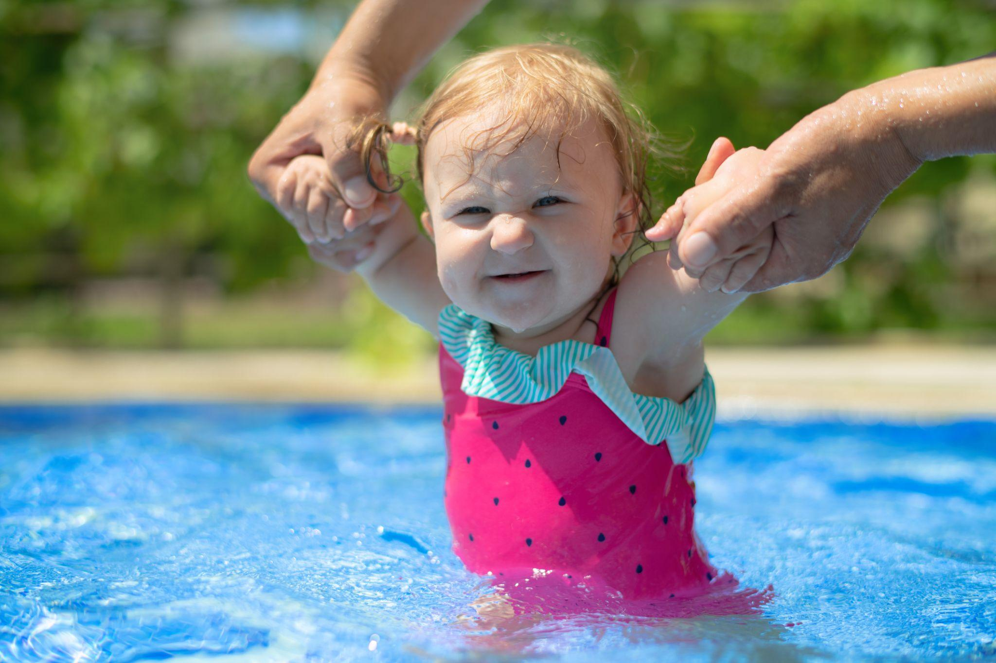

Summer is upon us—and that means splash pad visits, pool days, picnics, and lots of time outdoors. With little ones in tow, it’s important to remember that they are more sensitive to the heat and sun, as well as need extra precautions around water. To help prepare you for a relaxed and fun summer while keeping your kids safe, we’ve compiled some sun and water safety guidelines for infants, toddlers, and preschoolers.

### **Infants (0–12 Months)**

**Sun Safety** - Infants have delicate skin and limited ways to cool down or protect themselves. Keeping them shaded, cool, and supervised is the best way to go. Avoid direct sunlight for babies under 6 months, especially from 10 AM - 4 PM. Stroller canopies, sun hats, or umbrellas are perfect for when you have to be in the sun. Dress infants in lightweight, long-sleeved clothing that covers their arms and legs.Sunscreen for babies isn’t necessarily recommended, but if exposure is unavoidable, use a small amount of baby-safe sunscreen (SPF 30+) on exposed areas.

**Water Safety** - Water safety for infants involves constant, hands-on supervision. Your baby should always be within arm’s reach when near water—even shallow or still water. In pools, avoid inflatable floaties or seats that can tip over. Instead, gently hold your child during water play. Use warm, shallow water for splash time, and check the temperature before placing your baby in.

### **Toddlers (1–2 Years)**

**Sun Safety -** Sun safety for toddlers begins with applying a broad-spectrum, water-resistant sunscreen (SPF 30+) 15–30 minutes before outdoor play. Reapply every 2 hours or after swimming. Choose wide-brimmed hats and UV-protective sunglasses if your toddler will wear them. Offer frequent water breaks to keep them hydrated in the heat.

**Water Safety -** Toddlers love to explore, but they don’t yet understand the risks of water exposure. Constant supervision is key. Stay within arm’s reach when your toddler is in or near any body of water—even a small kiddie pool. Empty water tables, buckets, and baby pools after use to prevent accidents. Consider enrolling your toddler in a water play class or beginner swim lessons led by certified instructors—look for programs that follow AAP guidelines.

### **Preschoolers (3–5 Years)**

**Sun Safety -** Teach your child how to put on their own sunscreen (with supervision) and explain why it's important. Encourage shade breaks during play, especially during midday. Provide plenty of fluids to prevent overheating and dehydration.

**Water Safety -** Preschoolers may be more independent, but they still need close supervision and reminders about safety rules.Reinforce basic water rules like “no running,” “stay where I can see you,” and “ask before going in.” Consider swim lessons that focus not just on learning strokes, but also on water safety basics and confidence in the water. Use U.S. Coast Guard-approved life jackets when near lakes, pools, or other open water.

A few final tips - Getting sunlight is good for us! It increases vitamin D production and overall health. Just limit exposure between the hours of 10 AM and 4 PM. When near water, dress your child in brightly colored clothing and swimsuits so they can be easily spotted.

Our school always keeps safety as a top priority for our students. We know the importance of spending time outdoors, which is why we head outside twice a day, weather permitting. During the summer months, we make sure our students have sun protection and stay hydrated. Constant supervision is provided at all times, and especially during water play. To learn more about summers with us, contact us today!